Steps to Increase the Percentage of Security Health check.

1. Login into the sandbox.
2. Go to Setup by clicking on the gear icon
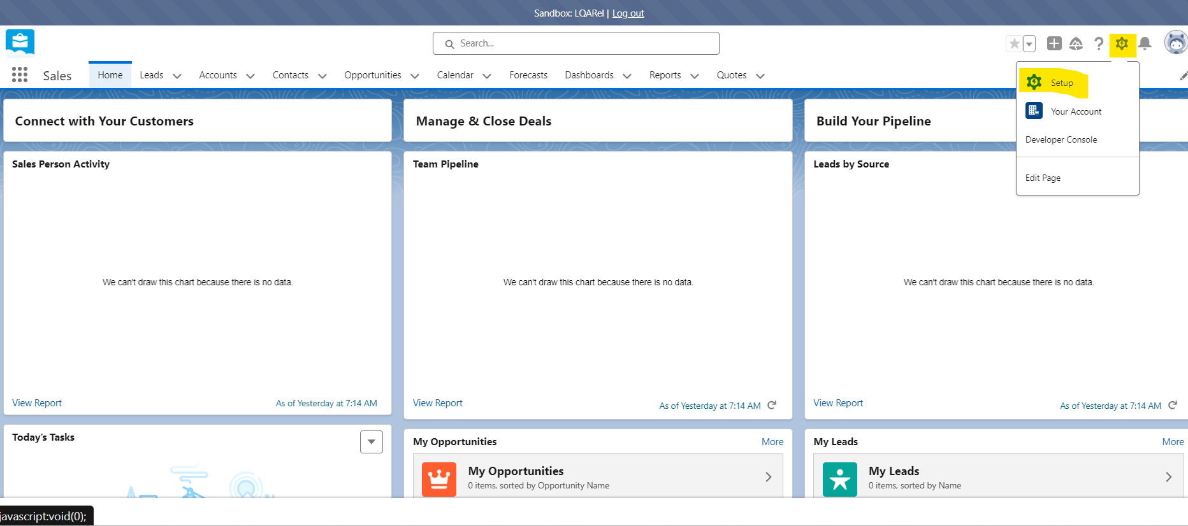
3. Search for Password Policies in the search bar and click on it
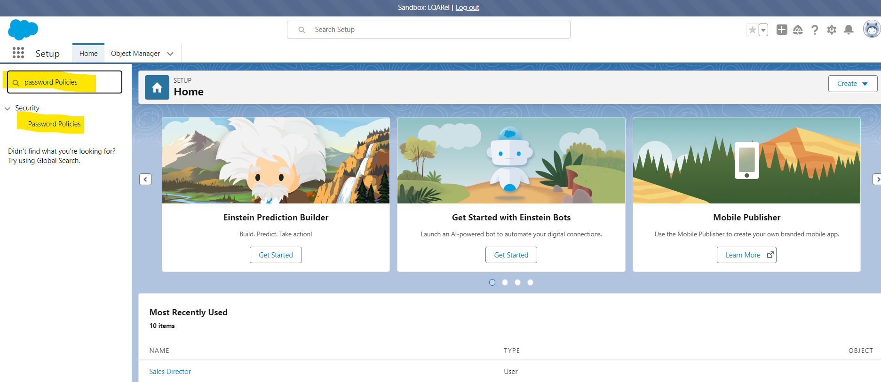
4. After Clicking on the Password Policies follow the below Steps,
  - Set the Maximum invalid login attempts to 3.
  - Select Must include alpha, numeric, and special Characters for Password Complexity requirement.
  - Obscure secret answer for password resets Checkbox should be Checked.
  - Set Lockout effective period to 30 minutes.
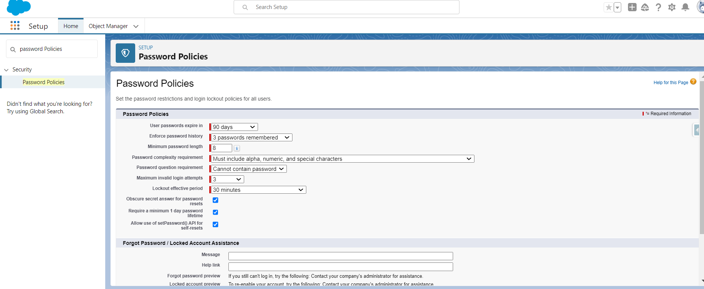
5. After following above steps run the Security health check the percentage will be 80%

